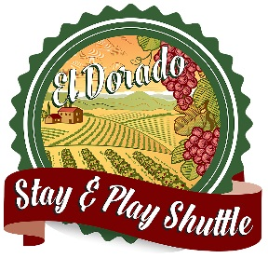
EL DORADO STAY AND PLAY SHUTTLE
Application Form
Today’s Date: _____________
How did you learn about the El Dorado Stay and Play Shuttle Program: _____________
___________________________________________________________________________

First Name: ___________________________ Last Name: _______________________________
E-mail: _____________________________ Phone Number: ________________________
Home Address: ___________________________________________
City: ____________________________ State: ___________________________________
Zip Code: ____________________________

Type of Event: ___________________ Date of Event:_________________
List all Lodging Properties where guests are staying
Lodging_________________________________
Address______________________________ City__________________________
Lodging_____________________________________
Address______________________________ City___________________________
Lodging_________________________________
Address______________________________ City__________________________

Room block or reservations under what name? ___________________________________
Estimate number of room nights? _____________________________
Pick Up Location/s
Name: ______________________________________________
Street Address: ________________________________________
City: _________________________________ Zip Code: __________________________

Name: ______________________________________________
Street Address: _______________________________________
City: _________________________________ Zip Code: __________________________

Drop-off Location/s
Venue Name: ______________________________________________
Street address: _________________________________________
City: _________________________________ Zip Code: _________________________

Special Instructions or comments:
__________________________________________________________________
__________________________________________________________________
__________________________________________________________________

The El Dorado Stay and Play Shuttle is funded by a grant from the El Dorado County Air Quality Management District. The El Dorado County Visitors Authority (EDVA designed the program to encourage group transportation and overnight stays in El Dorado County, reduce motor vehicle emissions and introduce new visitors to the area.

Sylvia Rubio
El Dorado Stay & Play Program Coordinator
stayandplay@eldoradocounty.org
530-621-5885
www.VisitEldorado.com

